Meeting called to order at 7:00 p.m. by President Kern with a salute to the flag.

Roll call was recorded as follows:

Present: D’Adamo, Dill, McGuigan, Smith, Tapp, Triboletti & Kern
Also Present: Mayor Glasser, Administrator Swain, Atty. Franklin & Clerk Degrassi & Deputy Clerk Samuelsen

Absent: None

***************
Open Public Meetings Act

Pursuant to the Open Public Meetings Act, adequate notice of this meeting has been provided. Agenda for this meeting has been provided to two local newspapers and posted in the City Clerk’s Office

***************

Council President Kern advised that she will be moving the agenda around to bring forward the ordinances, as follows:

Ordinance No. 13 - Final Reading
M/S - D’Adamo/Tapp
Meeting was opened to the public and duly closed. Ordinance No. 13 was then adopted on final reading by a unanimous vote of those present.

Ordinance No. 13 of 2014

An Ordinance Enacted Under Authority of N.J.S.A. 39:4-197 Regulating the Parking of Vehicles on Certain Streets and Portions Thereof and N.J.S.A. 40:48-2.46 granting the Authority to establish Handicapped Parking spaces, Amending and Supplementing the Somers Point Municipal Code Chapter 250 Vehicles and Traffic, Section 250-24 Schedule I: No Parking and Article III: Handicapped Parking, and Repealing All Ordinances Heretofore Adopted, the Provisions of Which Are Inconsistent Herewith.

FIRST READING: April 24, 2014
PUBLICATION: April 30, 2014
FINAL PASSAGE: May 8, 2014

***************
Ordinance No. 14 - Final Reading
M/S - D’Adamo/Dill
Meeting was opened to the public and duly closed. Ordinance No. 14 was then adopted on final reading by a unanimous vote of those present.

Ordinance No. 14 of 2014
AN ORDINANCE SUPPLEMENTING AND AMENDING CHAPTER 25 OF THE SOMERS POINT MUNICIPAL CODE ADDING SECTION 25-5.1 THROUGH 25-5.2; SUPPLEMENTING AND AMENDING CHAPTER 48 OF THE SOMERS POINT MUNICIPAL CODE ADDING SECTION 48-3.1 THROUGH 48-3.2; AND REPEALING ALL ORDINANCES HERETOFORE ADOPTED THE PROVISIONS OF WHICH ARE INCONSISTENT HEREWITH.

Page 2
Ordinance No. 14 (Continued)

FIRST READING: April 24, 2014
PUBLICATION: April 30, 2014
FINAL PASSAGE: May 8, 2014
***************
Ordinance No. 16 - Final Reading (TABLED)
M/S - Triboletti/Dill
Meeting was opened to the public and duly closed. Councilman D’Adamo proposed tabling this ordinance in order to review. Councilman Dill seconded the motion. Councilman Dill stated that he would go along with the tabling motion because of questions raised at the last meeting regarding the street paving. Tabling motion was then approved by a unanimous vote of those present.

ORDINANCE NO. 16 of 2014 (TABLED 5/8/14)

BOND ORDINANCE PROVIDING FOR VARIOUS IMPROVEMENTS AND ACQUISITIONS IN AND BY THE CITY OF SOMERS POINT, IN THE COUNTY OF ATLANTIC, NEW JERSEY APPROPRIATING $1,120,000 THEREFOR AND AUTHORIZING THE ISSUANCE $1,064,000 OF BONDS OR NOTES OF THE CITY TO FINANCE PART OF THE COST THEREOF.

First Reading: April 24, 2014
Publication: April 30, 2014
Second Reading: May 8, 2014 (Tabled)

***************
Ordinance No. 17 - Final Reading
M/S - D’Adamo/Dill
Adopted on final reading by a unanimous vote of those present.

ORDINANCE NO. 17 OF 2014

BOND ORDINANCE PROVIDING FOR VARIOUS SEWER UTILITY CAPITAL IMPROVEMENTS IN AND BY THE CITY OF SOMERS POINT, IN THE COUNTY OF ATLANTIC, NEW JERSEY, APPROPRIATING $500,000 THEREFOR AND AUTHORIZING THE ISSUANCE OF $475,000 BONDS OR NOTES OF THE CITY FOR FINANCING THE COST THEREOF.

FIRST READING: April 24, 2014
PUBLICATION: April 30, 2014
FINAL READING: May 8, 2014
PUBLICATION: May 14, 2014

***************

Public Portion on Resolutions

Meeting was opened to the public and duly closed.

***************
Page 3

Public Hearing on Budget Amendment (Resolution No. 91)

Council President Kern explained that the budget was introduced in early March, as required, and at the last meeting Council voted on the budget amendment. She stated that this is what we will be having the public hearing on tonight. She stated that the Council looks forward to doing things better in the future and here are some things they are looking at: Property tax rebate card for tax credits for Somers Point homeowners; discussion with Ocean City regarding shared services; efforts are being made to obtain grant monies and Mayor Glasser is still having continuing discussion with Linwood and Northfield for possible shared services for Superintendent of Schools. She also advised that we have a grant writer and have received $330,000 in grants and have engaged a local economist who will be examining the commercial corridor and ways to turn the empty property into ratables. She also pointed out that the tax rate in pennies has gone down from introduction, 5.45 to 3.96, a 1.49 cent reduction. She explained that the increase from 2013 to 2014 for an average home is $27.23 per year, or $2.27 per month.

Meeting was then opened to the public regarding the Budget Amendment, as follows:

A resident of Sunrise Avenue came forward and addressed the governing body asking if the $50,000 was still in the budget for the relocation of the tennis courts. Administrator Swain explained that this is an item in the Capital Ordinance and that the down payment for the capital ordinance is in the budget. He also asked if Wawa and Shore Orthopedic are being considered for this budget. Administrator Swain advised that he believes that Wawa is. Councilman Smith advised that they would go on as an added assessment which means that all of the money would come to the City.

George Leopold, 745 Bay Avenue, came forward and addressed the governing body thanking them for getting information on line quickly after the last meeting. He also asked how much money we have saved from the prior budget. Administrator Swain answered $176,829 of which $30,000 came from surplus.

Helen Feo, 745 Fifth Street, came forward and addressed the governing body asking about figuring out how much her increase in taxes will be. Administrator Swain explained how she could figure this out.

George Reale, 126 Exton Road, came forward and addressed the governing body thanking them for their efforts. He suggested that the City charge for someone to give tennis lessons at the courts.

Robert Lawless, 747 Bay Avenue, came forward and addressed the governing body thanking them for the extra work they have done.

Jack Franco, Decatur Avenue, came forward and addressed the governing body asking questions about the cuts that were made, and stating that he feels that shared services is the way to go.

Jackie Grady, 517 Bay Avenue, came forward and addressed the governing body asking about the impact of the closed businesses along Route 9. Administrator Swain stated that there is no doubt that there is an impact and added that part of the $330,000 grant will be to plan for the Route 9 commercial corridor.

Public portion was then closed. Council President Kern thanked everyone for coming.

***************

Resolution No. 91 (Budget Amendment
M/S - Dill/Tapp
Adopted by a unanimous vote of those present.

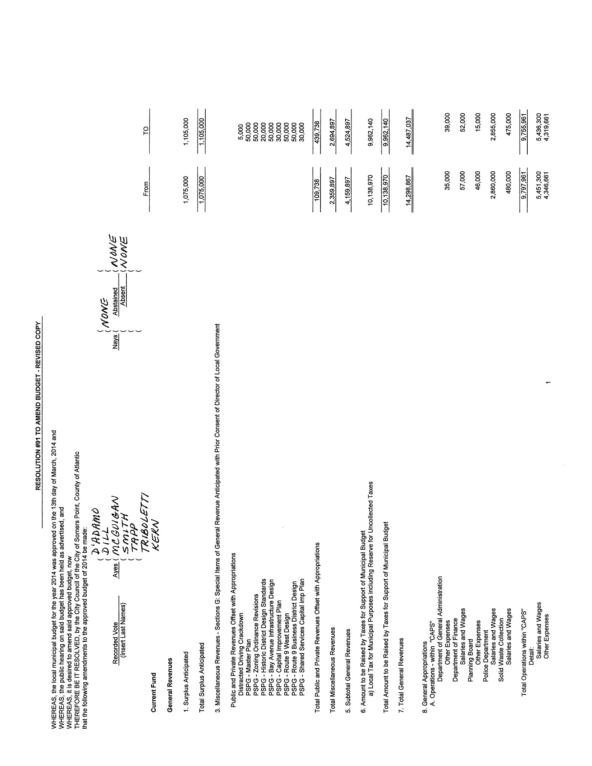
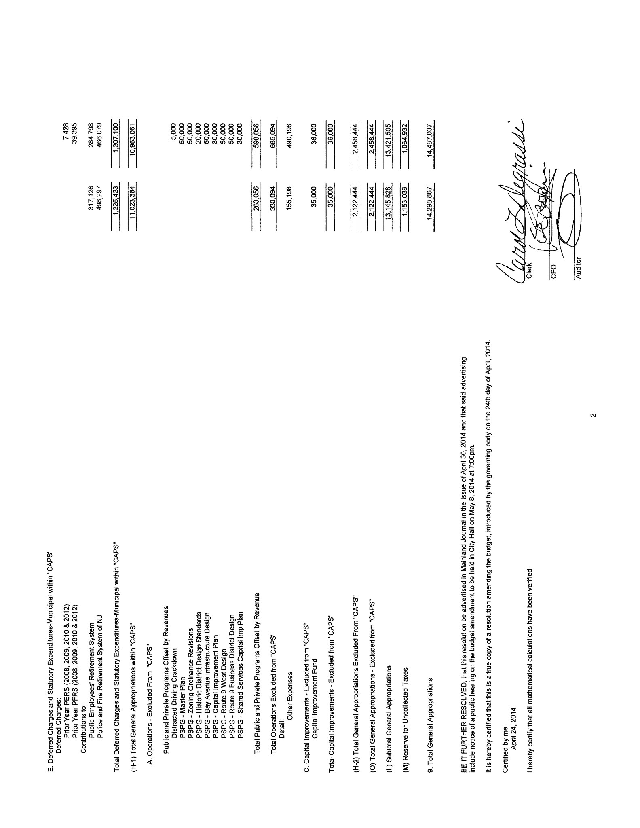

Page 6

Resolution No. 102 - Adoption of Budget, as amended
M/S - Dill/Tapp
Budget adopted, as amended, by a unanimous vote of those present.

No. 102 of 2014

BE IT RESOLVED by the City Council of the City of Somers Point, County of Atlantic that the budget hereinbefore set forth is hereby adopted and shall constitute an appropriation for the purposes stated of the sums therein set forth as appropriations, and authorization of the amount of $9,962,140. for municipal purposes.
RECORDED VOTE
( D’Adamo Abstained ( None
( Dill
( McGuigan
Ayes ( Smith Nays ( None
( Tapp
( Triboletti Absent ( None
( Kern

***************

Communications

Proclamation

The following proclamation was read in full by the City Clerk.

Supporting the Click It or Ticket Mobilization of May 19 – June 1, 2014

Whereas, there were 545 motor vehicle fatalities in New Jersey in 2013; and

Whereas, a large percentage of the motor vehicle occupants killed in traffic crashes were not wearing a seat belt; and

Whereas, use of a seat belt remains the most effective way to avoid death or serious injury in a motor vehicle crash; and

Whereas, the National Highway Traffic Safety Administration estimates that 135,000 lives were saved by safety belt usage nationally between 1975-2000; and

Whereas, the State of New Jersey will participate in the nationwide Click It or Ticket seat belt mobilization from May 19 – June 1, 2014 in an effort to raise awareness and increase seat belt usage through a combination of enforcement and education; and

Whereas, the Division of Highway Traffic Safety has set a goal of increasing the seat belt usage rate in the state from the current level of 91% to 92%; and

Whereas, a further increase in seat belt usage in New Jersey will save lives on our roadways;

Therefore, I, Mayor John L. Glasser, Jr., hereby proclaim that the City of Somers Point, County of Atlantic, State of New Jersey, declares its support for the Click It or Ticket seat belt mobilization both locally and nationally from May 19 – June 1, 2014 and pledges to increase awareness of the mobilization and the benefits of seat belt use.

***************
Page 7

Council President Kern thanked the Current for the article they did on Municipal Clerk’s week which included the Clerks from Somers Point, Linwood and Northfield.

Mayor’s Report

Mayor Glasser thanked the Bayfest Committee and all those who work so hard on this event which is the kick off to our summer season. He then gave the Police Department report for the month of April in full, stating that next week is National Police Week. He also reported that through the efforts of Administrator Swain and Engineer Schneider, we have received a grantg for $190,000 for the paving of Bala Drive.

***************

Resolution No. 103
M/S - Dill/Tapp
Adopted by a unanimous vote of those present.

No. 103 of 2014

Subject: Chapter 159 Resolution

Introduced By: Council President Kern

WHEREAS, N.J.S.A. 40A:4-87 provides that the Director of the Division of Local Government may approve the insertion of any special item of revenue in the budget of any municipality when such item shall have been made available by law and the amount thereof was not determined at the time of the adoption of the budget; and

WHEREAS, said Director may also approve the insertion of an item of appropriation for equal amount; and

WHEREAS, the City of Somers Point has received a grant of $4,000.00 and wishes to amend its 2014 budget to include this amount as a revenue.

NOW, THEREFORE, BE IT RESOLVED that the City Council of the City of Somers Point hereby requests the Director of the Division of Local Government Services to approve the insertion of an item of revenue in the budget of the year 2014 in the sum of $4,000.00 which item is now available as a revenue from:

Miscellaneous Revenue
Special Items of General Revenue Anticipated with Prior Written Consent of the Director of Local Government Services:
Public and Private Revenue Offset with Appropriations:
NJ Division of Highway Traffic Safety
Click It or Ticket 2014 Mobilization $4,000.00

pursuant to the provision of Statute; and

BE IT FURTHER RESOLVED that a like sum of $4,000.00 be and the same is hereby appropriated under the caption of:

General Appropriations
( A ) Operations - Excluded from “CAPS”
Public and Private Programs Offset by Revenues:
NJ DHTS Click It or Ticket 2014 Mobilization $4,000.00

Page 8
Resolution No. 103 (Continued)

BE IT FURTHER RESOLVED that two ( 2 ) copies of this resolution be certified and submitted to the Director of Local Government Services for approval.

***************

Administrator’s Report

There was no Administrator’s Report.

Committee Reports

Councilman D’Adamo reported that the Steering Committee has been to the Historic Commission, Recreation & Planning, stating that it is a lengthy operation. He stated that they have a tentative date of June 18th for a public meeting and he will see that Council gets the agenda.

***************

Minutes

There were no minutes presented for approval.

***************

Old Business

Councilman Dill asked Administrator Swain for an update regarding the locks at the Tennis Courts. Administrator Swain stated that it was scheduled for last week, but doesn’t know if it has been completed. He stated that he will check on it tomorrow.

New Business

Raffle License application for the Knights of Columbus was approved by a 6-0 vote with Councilman D’Adamo abstaining.

Bingo License application for the Community Partnership for Egg Harbor Township Schools was approved by a unanimous vote of those present.

Discussion of Bills

Bills were presented for discussion in the amount of $105,849.88. Administrator Swain asked that $2000.00 on Page 4, #14957723 be deleted making the total bill list $103,849.88. A report of invoices paid was also reported in the amount of $16,205.38.

Public Portion

Patti Cianci, Higbee Avenue, came forward and addressed the governing body asking why the Mainland Channel wasn’t airing the last Council meeting.

Helen Feo, 745 Fifth Street, came forward and addressed the governing body asking about the tax credit program that the City is looking into. Council explained that the Economic Development Advisory Commission is looking into this and explained that the local businesses would have to buy into this program.

***************

Page 9

Payment of Bills
M/S - Triboletti/Dill
Approved by a unanimous vote of those present. A complete list of bills is on file in the Office of the Municipal Clerk.

***************

Adjournment

There being no further business, meeting adjourned at 8:11 p.m.

***************

Carol L. Degrassi, RMC/MMC
Municipal Clerk

Approved: 05/29/14

